|  |
| --- |
| IFMR RURAL FINANCE |
| Lead Generation |
|  |
| **IFMR Rural Finance** |
| **11/9/2016** |

|  |
| --- |
|  |

Contents

Process Diagram 4

1. Stage definition 5

2. Stage-role access 5

3. Bulk lead data upload 5

3.1 UI specification (Data Upload File) 5

3.2 Screenshot 5

3.3 Functional Requirements 6

3.4 Uploads 6

3.5 Downloads 6

3.6 Reports 7

4. assigning leads (ASSIGNMENT PENDING QUEUE) 7

4.1 UI Requirements (Assignment Pending) 7

4.2 Screenshots 8

4.3 Functional Requirements 10

4.4 Uploads 10

4.5 Downloads 10

4.6 Reports 10

5. Capturing Lead Details & Decision Making 11

5.1 UI Requirements (data Fields) 11

5.2 Screenshots 16

5.3 Functional Requirements 18

5.4 Uploads 19

5.5 Downloads 19

5.6 Reports 19

6. Incomplete Leads Queue 19

6.1 UI Requirements (data Fields) 19

6.2 Screenshots 19

6.3 Functional Requirements 20

6.4 Uploads 20

6.5 Downloads 20

6.6 Reports 20

7. follow- up queue 21

7.1 UI requirements (Queue Layout) 21

7.2 Screenshots 21

7.3 Functional requirements 22

7.4 Uploads 22

7.5 Downloads 22

7.6 Reports 22

# Process Diagram

# 

C:\Users\sarthak.shah\AppData\Local\Microsoft\Windows\INetCache\Content.Word\lead generation v2.png

# Stage definition

|  |  |
| --- | --- |
| **Stage** | **Description** |
| Bulk Lead data Upload | The Central Marketing Team creates an excel with the list of leads and uploads the excel with Hub Name in the system |
| Assigning Leads | Hub Manager assigns leads to spoke. All such leads will be stored in “Incomplete Leads” queue |
| Capturing Lead details & Decision making | The Loan Officer uses the Lead Generation screen to fill details about a specific lead, either by creating a fresh lead or working on ones assigned by the Hub Manager. |
| Incomplete Leads Queue | For cases where leads are assigned by the hub manager, in order to capture complete information, loan officer selects a lead from the Incomplete Leads queue. |
| Follow up queue | The leads kept for follow up are actioned upon on the follow- up date. |

# Stage-role access

|  |  |
| --- | --- |
| **Stage** | **Applicable Role** |
| Bulk Lead Data Upload | Central Marketing Team |
| Assigning Leads | Hub Manager |
| Capturing Lead details & Decision making | Loan Officer |
| Incomplete Leads Queue | Loan Officer |
| Follow up queue | Loan Officer |

# Bulk lead data upload

## UI specification (Data Upload File)



## Screenshot

|  |  |  |  |  |
| --- | --- | --- | --- | --- |
|  |  |  |  |  |
| |  | | --- | |  | |  |  |  |  |
|  |  |  |  |  |
|  |  |  |  |  |
|  |  |  |  |  |
|  |  |  |  |  |
|  |  |  |  |  |
|  |  |  |  |  |
|  |  |  |  |  |
|  |  |  |  |  |
|  |  |  |  |  |
|  |  |  |  |  |
|  |  |  |  |  |
| |  | | --- | |  | |  |  |  |  |
|  |  |  |  |  |
|  |  |  |  |  |
|  |  |  |  |  |
|  |  |  |  |  |
|  |  |  |  |  |
|  |  |  |  |  |
|  |  |  |  |  |
|  |  |  |  |  |
|  |  |  |  |  |
|  |  |  |  |  |

## Functional Requirements

**Central Marketing Manager** logs in.

1. Creates an excel sheet with the list of leads (in the prescribed format shared and agreed) and uploads the excel, in the system.
2. Leads uploaded in the system should appear in the respective Hub Manager login (based on the hub, and the hub manager mapped to it).
3. After successful upload, the status of these leads can be “assignment pending”

## Uploads

The lead data upload spreadsheet

## Downloads

NA

## Reports

Lead Generation report

# assigning leads (ASSIGNMENT PENDING QUEUE)

## UI Requirements (Assignment Pending)

|  |  |  |  |  |
| --- | --- | --- | --- | --- |
| **Field name** | **Section** | **Data Type** | **Attribute** | **Population logic** |
| Upload Date | Assigning Leads | date | Sort/search | Auto-populated (From uploaded file during bulk data upload) |
| Lead Name | Assigning Leads | Text | Sort/search | Auto-populated (From uploaded file during bulk data upload) |
| Business Name | Assigning Leads | Alphanumeric | Sort/search | Auto-populated (From uploaded file during bulk data upload) |
| Address | Assigning Leads | Alphanumeric |  | Auto-populated (From uploaded file during bulk data upload) |
| Area | Assigning Leads | Text | Sort/search | Auto-populated (From uploaded file during bulk data upload) |
| City/Village/Town | Assigning Leads | Text | Sort/search | Auto-populated (From uploaded file during bulk data upload) |
| Pincode | Assigning Leads | Numeric |  | Auto-populated(From uploaded file during bulk data upload) |

## Screenshots

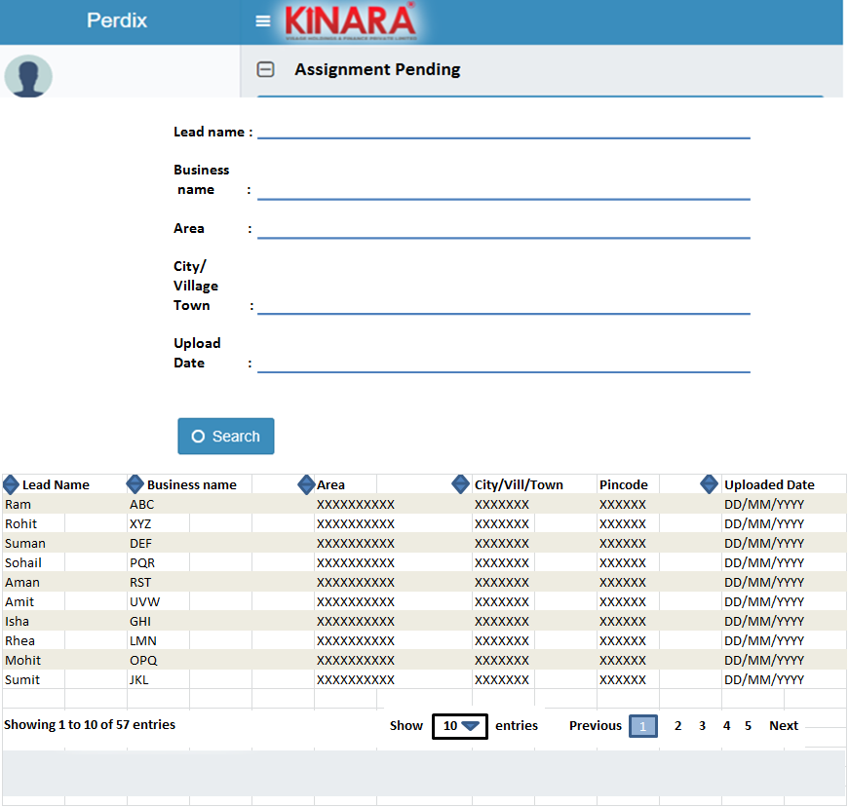

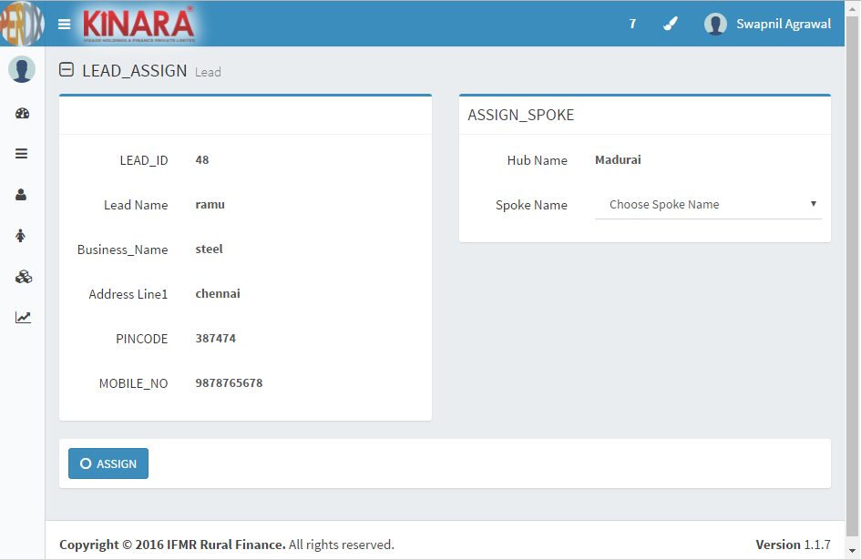

## Functional Requirements

**Hub Manager** logs in,

* 1. All the leads which are assigned to particular Hub Manager should get displayed here.
  2. The hub manager will assign leads which are in “assignment pending” stage to spoke.
  3. Upon selecting the assignment pending queue, all cases pertaining to the particular hub need to be listed in a tabulation (**based on the Hub ID**).
  4. Leads are assigned to a spoke by selecting from a dropdown of all the spokes mapped to that particular hub. Prior to assignment, the hub manager can **sort** these leads based on the following parameters: Upload date, Lead Name, Business Name, Area, City/Village/town.
  5. Once assigned, leads should appear in the Loan Officer’s log-in (based on the spoke he is mapped to- **using spoke ID**).
  6. An option to reassign the lead needs to be provided in case the lead is erroneously assigned.
  7. After successful assignment, lead status can be “Assigned”.

## Uploads

N.A.

## Downloads

N.A.

## Reports

Lead Generation Report

# Capturing Lead Details & Decision Making

## UI Requirements (data Fields)

|  |  |  |  |  |  |  |
| --- | --- | --- | --- | --- | --- | --- |
| **Section** | **Sub section** | **Field Name** | **Field Value** | **Mandatory** | **Conditional Mandatory** | **Remarks** |
| Lead Profile |  | Hub Name | Alphanumeric | Yes |  | Auto-populate based on log in |
|  | Spoke Name | Alphanumeric | Yes |  | Auto-populate based on log in. If a loan officer is mapped to more than one spoke then select option |
| Lead Details | Lead Name | Text | Yes |  |  |
| Entity Type | Dropdown | Yes |  | Individual / Enterprise |
| Individual Details | Gender | Radio button | Yes |  | Male/Female/Unspecified- |
| Date of Birth | Date | Yes |  |  |
| Age | Numeric |  |  | Autocalculated |
| Marital Status | Dropdown | Yes |  | Divorced/Married/Single/Widow/Seperated |
| Education Status | Dropdown |  |  | Below SSC/SSLC/HSC, (Graduate/Diploma/ITI)/Professional Degree/Others |
| Enterprise Details | Business Name | alphanumeric |  | Yes | Mandatory if entity type is Enterprise |
| Business Type | Dropdown |  | Yes | Manufacturing/Trading/Services  Refer lead dropdowns  Mandatory if entity type is Enterprise |
| Business Activity | Dropdown |  | Yes | If Business Type is Manufacturing then-> Sales/Jobwork  If Business Type is Trading then-> Wholesale/Retail  If Business Type is Services then-> B2B/B2C  Refer lead dropdowns  Mandatory if entity type is Enterprise |
| Add Button |  |  |  | In case more than one business type |
| Operating Since | Date |  | Yes | Mandatory if entity type is Enterprise |
| Ownership | Dropdown |  | Yes | Owned, Rented, Leased  Mandatory if entity type is Enterprise |
| Is the Business Registered? | Radio Buttons |  | Yes | Yes/No-  Mandatory if entity type is Enterprise |
| Contact Details | Mobile No. | Numeric | Yes |  | Validate – 10 digits |
| Alternate mobile number | Numeric |  |  | Validate – 10 digits |
| Address Line 1 | Alphanumeric | Yes |  |  |
| Address Line 2 | Alphanumeric |  |  |  |
| Pin code | Numeric | Yes |  | Pincode master |
| District | Text |  |  | Auto-populate based on Pincode master |
| State | Text |  |  | Auto-populate based on Pincode master |
| Location | GPS |  |  |  |
| Area | Text | Yes |  | (Provide Search Option)  Based on the respective spoke dropdown options required |
| Product Details |  | Product Category | Dropdown | Yes |  | Asset / Liability/Others |
| Product Sub- Category | Dropdown | Yes |  | Refer lead dropdowns  For Asset-> Loan/SA1/SA2  For Liability-> SL1/SL2/SL3 |
| Interested In product | Dropdown | Yes |  | Yes/No |
| Product Required by? | Drodown |  | yes | In this week/In this month/Next2-3 months/next4-6 months  Refer Lead Dropdowns tab.  Product category asset and sub category loan  (To be populated if the answer to "interested in product is Yes") |
| Scheduled screening date | Date |  | Yes | If interested & and loan required by ?- within this week |
| Scheduled follow up date | Date |  | Yes | If interested & and loan required by ?- other than within this week |
| Remarks | Alphanumeric (free text) |  |  |  |
| Loan purpose | Dropdown |  | yes | Refer Lead Dropdowns tab. Product category asset and sub category loan (To be populated if the answer to "interested in product is Yes") |
| Loan Amount Requested | Numeric |  | Yes | Product category asset and sub category loan (To be populated if the answer to "interested in product is Yes") |
| Product Eligibility | Eligible for Product | Radio Buttons |  | Yes | Yes/No- If interested in product is selected as Yes |
| Rejection Reason | Dropdown |  | Yes | Has many running loans/available from banks/Not planned for now/Interest rate is not satisfactory/ Too many documents/Interested only for cash collection  Populate only if Eligible for product is no |
| Additional remarks | Alphanumeric (free text) |  |  | (To be populated if the answer to "eligible for product is No") |
|  |  |  |  |  |  |
|  |  |  |  |  |
| Lead Status | Lead Status | Dropdown | Yes |  | Customer/Follow-up/Hold/Reject |
| Note: For all other product category/ sub category combinations, 3 sets of Field name/Field Values to be populated- Field name-1, Field name-2, Field name- 3 | | | | | |
| Customer Interactions |  | Interaction Date | Date | Yes |  | Auto Populate |
| Action Taken by (Loan Officer ID) | Alphanumeric | Yes |  | Auto Populate (based on login) |
| Type of interaction | Dropdown | Yes |  | Call / Visit |
| Location | GPS |  | Yes | if visit |
| Picture | Picture |  | Yes | if visit |
| Customer Response | Alphanumeric | Yes |  |  |
| Additional remarks | Alphanumeric |  |  |  |
| Note: A separate tab "Interactions History" to contain all previous customer interaction details in the above mentioned format | | | | | |
| Interaction History | Interaction Date | Date | Yes |  | Based on previous interaction |
| Action Taken by (Loan Officer ID) | Alphanumeric | Yes |  | Based on previous interaction |
| Type of interaction | Dropdown | Yes |  | Based on previous interaction |
| Location | GPS coordinates |  | Yes | Based on previous interaction |
| Picture | Picture |  | Yes | Based on previous interaction |
| Customer Response | Alphanumeric | Yes |  | Based on previous interaction |
| Additional remarks | Alphanumeric |  |  | Based on previous interaction |

## Screenshots

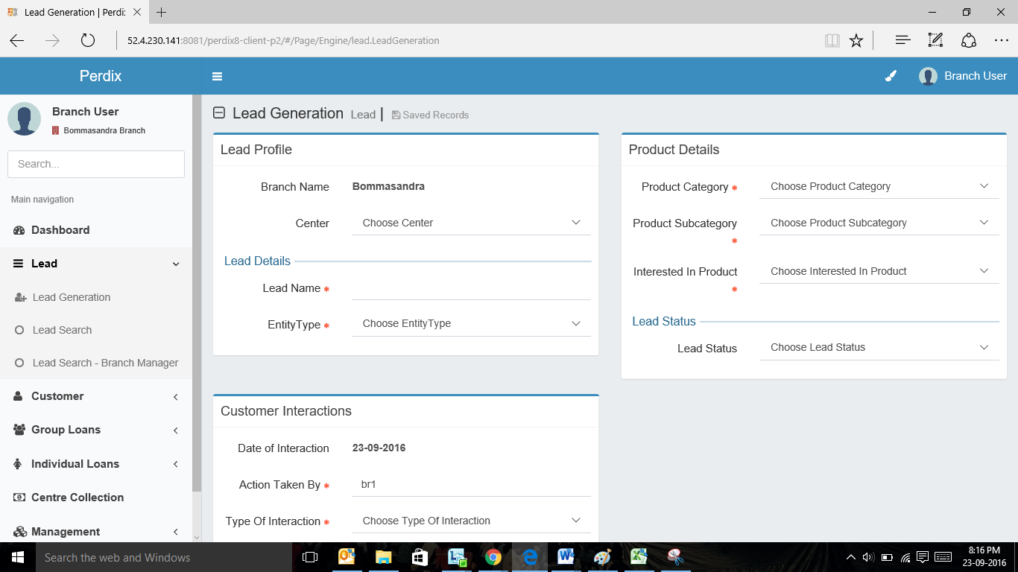

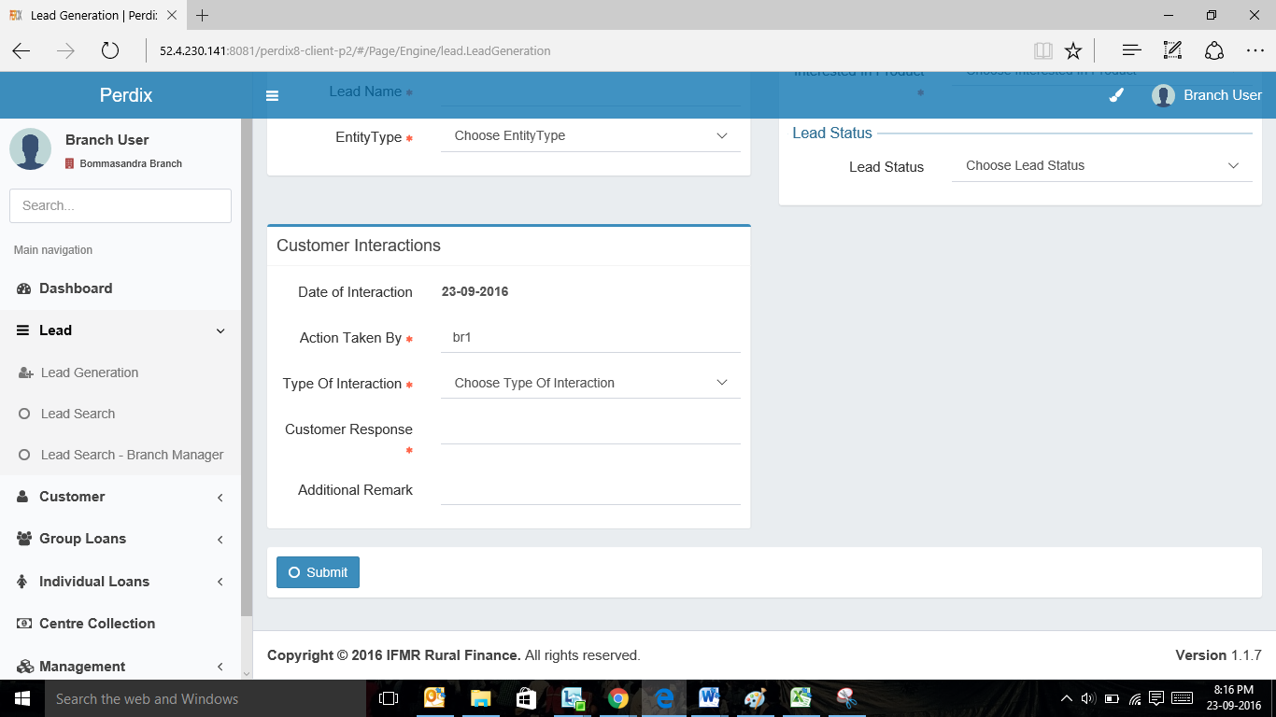

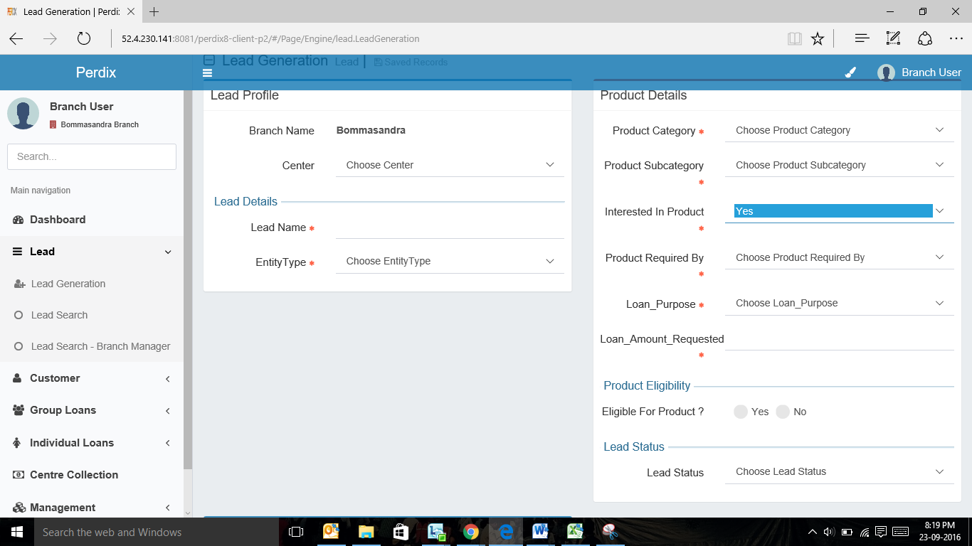

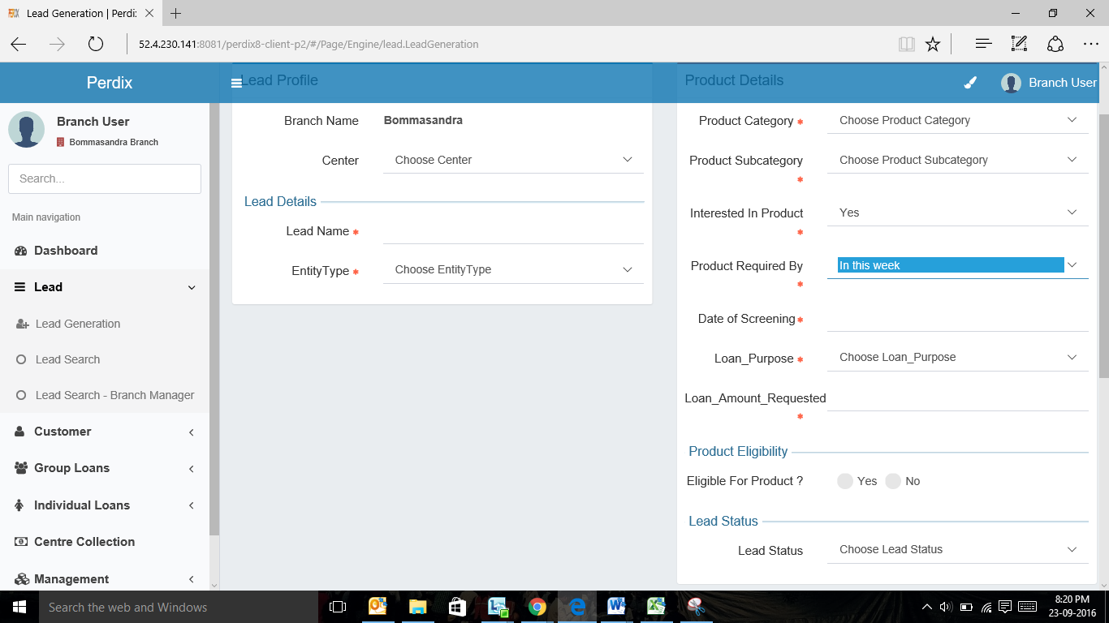

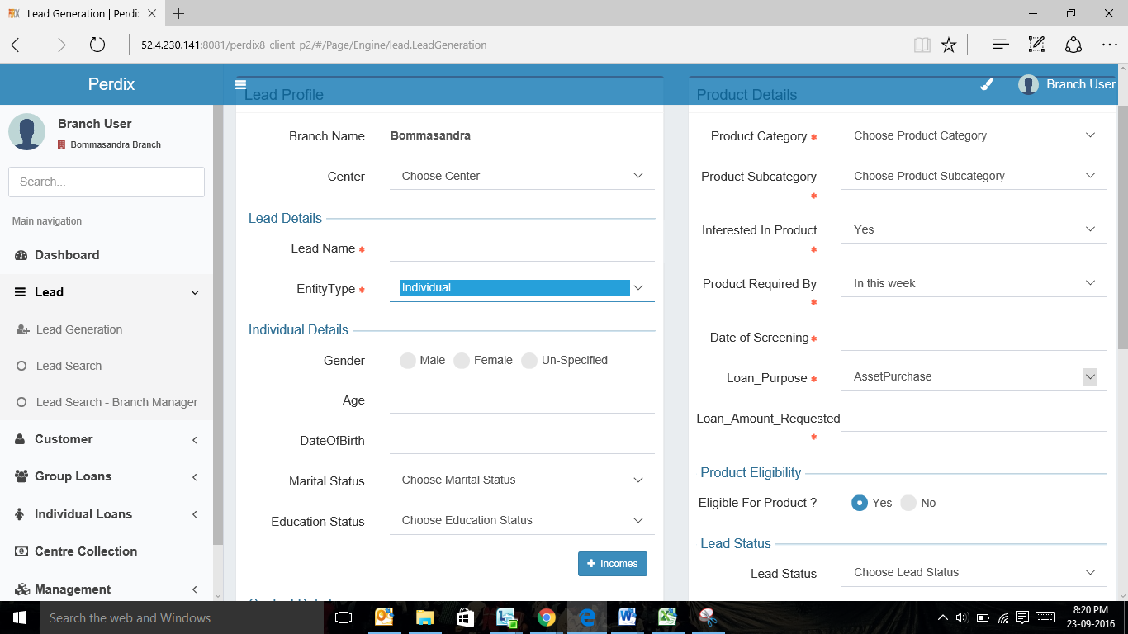

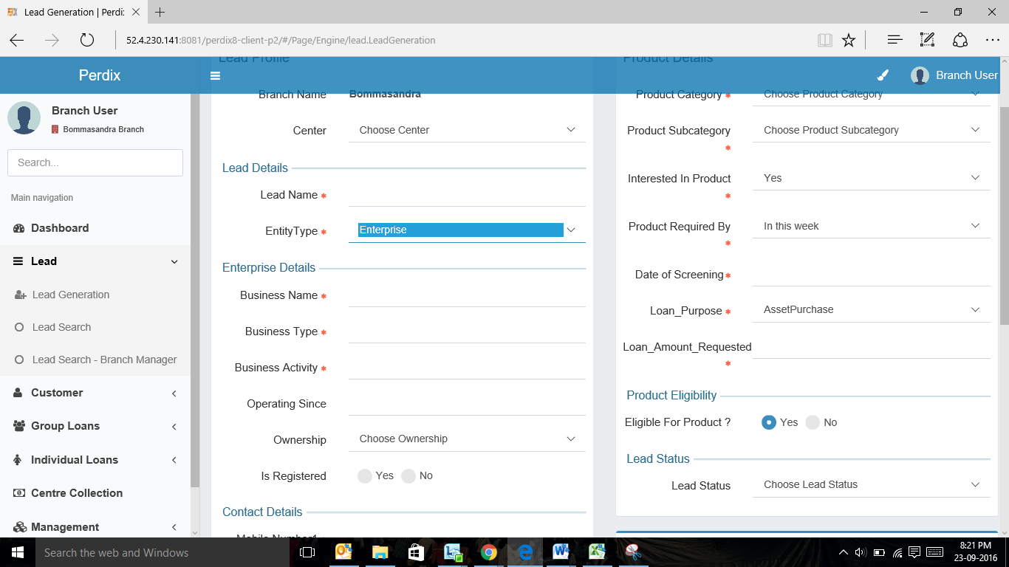

## Functional Requirements

**Loan Officer Logs** in

1. Loan Officer will land on this screen when he will select either fresh lead or lead from incomplete leads queue.
2. For leads generated by the Loan officer, the loan officer uses the ‘Create New Lead’ screen to fill details about a specific lead.
3. If entity type is Individual then only Individual details will be captured. If entity type is Enterprise then both Individual and Enterprise details will be captured.
4. Loan officer to capture the relevant data including the customer interaction information.
5. Based on the lead details captured, there would be various outcomes. If the “Interested in Product” field is captured as “no”, the loan officer needs to select the reason for the same. The profile is automatically rejected (status) upon submission.
6. If the loan officer finds the lead as not eligible to avail the product, the field “Eligible for Product” is selected as “No”, and then the Loan officer needs to select rejection reason and the profile is rejected (status) upon submission.
7. If an eligible lead requires the product immediately (within this week), then loan officer to enter screening date. Upon submission, customer ID is generated and the lead is moved to screening queue and its status can be changed to “Pending for Screening.”
8. If an eligible lead requires the product later, then the loan officer to enter follow-up date. The profile is sent to follow-up queue upon submission. Upon successfully adding lead for follow-up the status of the lead can be changed as “Follow up”

## Uploads

## Downloads

## Reports

1. Lead Management Funnel - Number of leads generated, number of approved, number of rejected, number of follow- up and number of disbursed
2. Lead Category Report- Hot, Warm, and Cold (based on the “product required by” field

# Incomplete Leads Queue

## UI Requirements (data Fields)

|  |  |  |  |  |
| --- | --- | --- | --- | --- |
| **Field name** | **Section** | **Data Type** | **Attribute** | **Population logic** |
|  |  |  |  |  |
| Assigned Date | Incomplete Queue | date | Sort |  |
| Lead Name | Incomplete Queue | Text | Sort/search |  |
| Business Name | Incomplete Queue | Alphanumeric | Sort/search |  |
| Address | Incomplete Queue | Alphanumeric |  |  |
| Area | Incomplete Queue | Text | Sort/search |  |
| City/Village/Town | Incomplete Queue | Text | Sort/search |  |
| Pincode | Incomplete Queue | Numeric |  |  |

## Screenshots

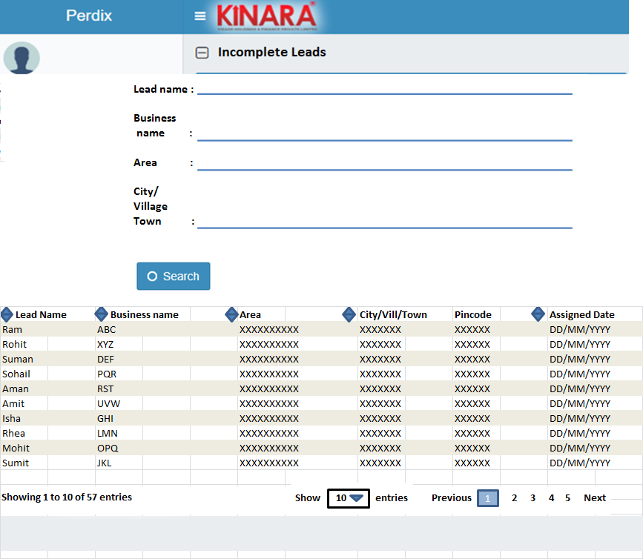

## Functional Requirements

**Loan Officer Logs** in

1. The loan officer opens the Incomplete Leads queue. All the leads with possible “Assigned” status will be displayed here.
2. Upon entering the incomplete lead queue, the loan officer can **search** for the leads using the following parameters: Assigned date, Lead name, Business name and area. The results need to be populated in a tabular format (UI purpose).
3. The loan officer can **sort** the incomplete leads based on the following parameters: Assigned date, Lead Name, Business Name, Area, City/Village/Town.
4. The loan officer then selects a lead from the incomplete leads queue (which was previously assigned to the respective spoke by the hub manager) and will start capturing the required information in the same way as explained in step 6.

## Uploads

N.A.

## Downloads

N.A.

## Reports

# follow- up queue

## UI requirements (Queue Layout)

|  |  |  |  |  |
| --- | --- | --- | --- | --- |
| **Field name** | **Section** | **Data Type** | **Attribute** | **Population logic** |
|  |  |  |  |  |
| Follow up Date | Follow-up Queue | date | Sort/Search | From data captured |
| Lead Name | Follow-up Queue | Text | Sort/Search | From data captured |
| Business Name | Follow-up Queue | Alphanumeric | Sort/Search | From data captured |
| Address | Follow-up Queue | Alphanumeric |  | From data captured |
| Area | Follow-up Queue | Text | Sort/Search | From data captured |
| City/Village/Town | Follow-up Queue | Text | Sort/search | From data captured |
| Pin code | Follow-up Queue | Numeric |  | From data captured |

## Screenshots

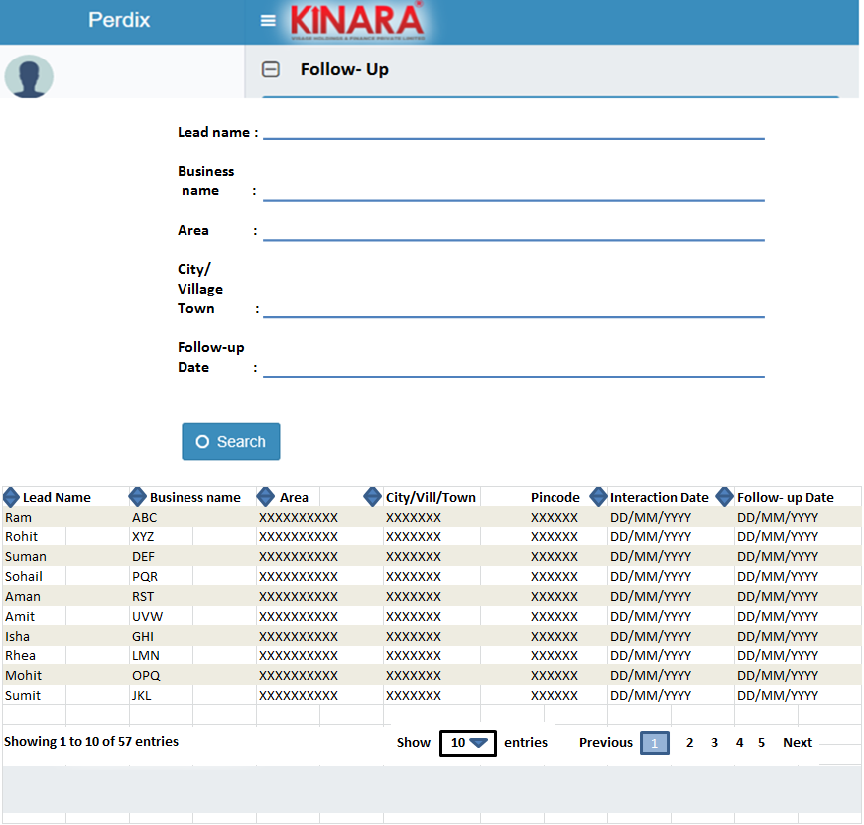

## Functional requirements

**Loan Officer** logs in

* 1. All the leads will be displayed which are mapped with loan officer on the basis of search parameter entered.
  2. The loan officer enters the Follow- up queue. Upon entering the Follow- up queue, the loan officer can **search** for the leads using the following parameters: Follow- up date, lead name , business name, area and City/Village/Town.
  3. The result will be displayed in a tabular format.
  4. The loan officer can sort these leads based on the following parameters: Follow up date, Lead Name , Business name, Area, City/Village/Town.
  5. The loan officer then selects a lead from the Leads in the Follow- up queue.
  6. Loan officer to follow up with the customer, update the fields and take a decision on the lead status (follow step 6). Accordingly the lead status will be updated.

## Uploads

## Downloads

## Reports

Number of leads to follow- up, responded and turned down.